**Batch: D - 1 Roll No.: 16010122096**

**Experiment / assignment / tutorial No. 01**

**Grade: AA / AB / BB / BC / CC / CD /DD**

**Signature of the Staff In-charge with date**

**Experiment No. 1**

|  |
| --- |
| **TITLE:**  Study of Networking devices (Hub, router, Gateway, Switch etc.) and Transmission Media |

**___________________________________________________________________________**

**AIM:** To study different Networking devices and transmission media used in day to day networks.

**_________________________________________________________________________­­**

**Expected Outcome of Experiment:**

**CO:**

**___________________________________________________________________________**

**Books/ Journals/ Websites referred:**

1. A. S. Tanenbaum, “Computer Networks”, Pearson Education, Fourth Edition
2. B. A. Forouzan, “Data Communications and Networking”, TMH, Fourth Edition

___________________________________________________________________________

**Pre Lab/ Prior Concepts:** Basics of LAN and Connecting devices

**___________________________________________________________________________**

**New Concepts to be learned:** Layer wise connecting devices

**___________________________________________________________________________**

**Stepwise-Procedure:**

.

**Study of Connecting Devices**

**1. Hub**

Hub in networking plays a vital role in data transmission and broadcasting. A hub is a hardware device used at the physical layer to connect multiple devices in the network. Hubs are widely used to connect LANs. A hub has multiple ports. Unlike a switch, a hub cannot filter the data, i.e. it cannot identify the destination of the packet, So it broadcasts or sends the message to each port.

What is HUB?

A hub is a multi-port repeater. A hub connects multiple wires coming from different branches, for example, the connector in star topology which connects different stations. Hubs cannot filter data, so data packets are sent to all connected devices.  In other words, the collision domain of all hosts connected through hub remains one. Hub does not have any routing table to store the data of ports and map destination addresses., the routing table is used to send/broadcast information across all the ports.

How Does a Network Hub Work?

A hub is a multiport device, which has multiple ports in a device and shares the data to multiple ports altogether. A hub acts as a dumb switch that does not know, which data needs to be forwarded where so it broadcasts or sends the data to each port.

**2. Repeater**

Repeaters are defined as a networking device that is used to amplify and generate the incoming signal. Repeaters work at the [physical layer of the OSI model](https://www.geeksforgeeks.org/physical-layer-in-osi-model/). The main aim of using a repeater is to increase the networking distance by increasing the strength and quality of signals. The performance of [Local Area Networks (LANs)](https://www.geeksforgeeks.org/lan-full-form/) and [Wide Area Networks (WANs)](https://www.geeksforgeeks.org/wan-full-form/) repeaters are used. Using repeaters helps to reduce error, and loss of data and provides with delivery of data at specified locations only. The major advantage of using a repeater is that it provides with transfer of data with more security and over a long distance.

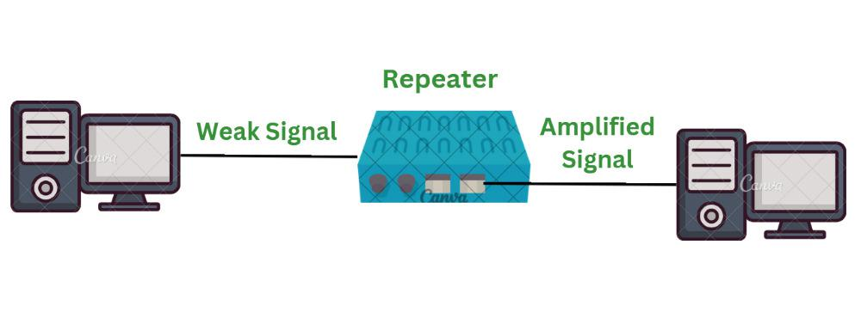

**3. Switch**

Switch

The Switch is a network device that is used to segment the networks into different subnetworks called subnets or LAN segments. It is responsible for filtering and forwarding the packets between LAN segments based on [MAC address](https://www.geeksforgeeks.org/introduction-of-mac-address-in-computer-network/).

Switches have many ports, and when data arrives at any port, the destination address is examined first and some checks are also done and then it is processed to the devices. Different types of communication are supported here like unicast, multicast, and broadcast communication.

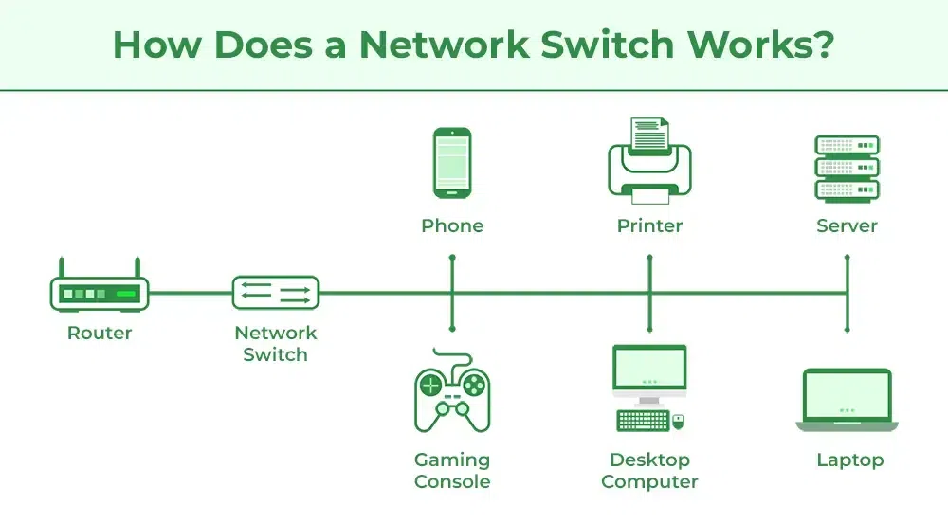

**4. Bridge**

The bridge is a networking device in a computer network that is used to connect multiple LANs to a larger LAN. In computer networks, we have multiple networking devices such as bridges, hubs, routers, switches, etc, each device has its own specification and is used for a particular purpose. The bridge is a networking device that connects the larger LAN networks with the group of smaller LAN networks.

In this article, we are going to discuss everything about the bridge including what exactly a bridge is, and the type of bridges we have in computer networks including transparent bridges, source routing bridges, and translational bridges, which will be followed by advantages and disadvantages of the bridge in networking. then how the bridge is different from the gateway and last we will look into the applications and functions of the bridge in the network.

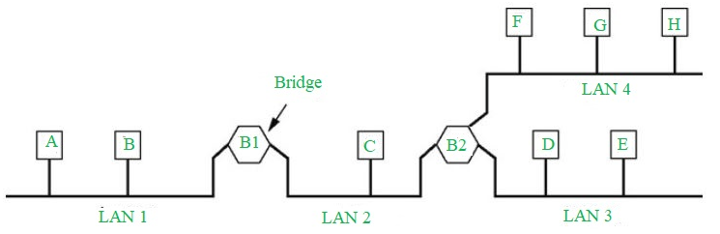

**5. Router**

A Router is a networking device that forwards data packets between computer networks. One or more [packet-switched networks](https://www.geeksforgeeks.org/packet-switched-network-psn-in-networking/) or subnetworks can be connected using a router. By sending data packets to their intended [IP addresses](https://www.geeksforgeeks.org/what-is-an-ip-address/), it manages traffic between different networks and permits several devices to share an [Internet connection](https://www.geeksforgeeks.org/types-of-internet-connection/).

Let us understand this by a very general example, suppose you search for *www.google.com* in your web browser then this will be a request that will be sent from your system to Google`s server to serve that webpage, now your request which is nothing but a stream of packets don`t just go to the google`s server straightaway they go through a series of networking devices known as a router which accepts this packets and forwards them to correct path and hence it reaches to the destination server. A router has several interfaces by which it can connect to several host systems. Routers are the devices that are operated on the Network Layer of the OSI Model, these are the most common devices used in networking.

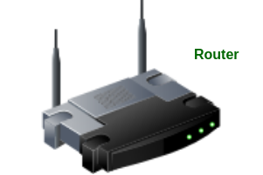

**6. Gateway**

A network gateway is a device that connects different networks by translating messages from one protocol into another protocol. The gateway monitors and controls all the incoming and outgoing [network traffic](https://www.geeksforgeeks.org/scraping-data-in-network-traffic-using-python/). Gateways are also known as protocol converters because they play an important role in converting protocols supported by traffic on different networks. As a result, it allows smooth communication between two networks.

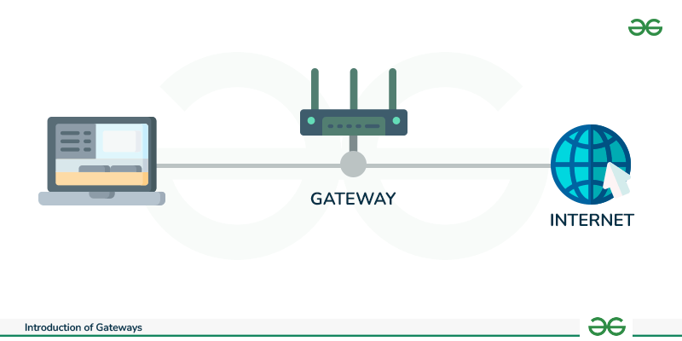

**7. NIC**

A network interface card (NIC) is a hardware component without which a computer cannot be connected over a network. It is a circuit board installed in a computer that provides a dedicated network connection to the computer. It is also called network interface controller, network adapter, or LAN adapter.

**NIC** stands for **Network Interface Card** NIC is additionally called Ethernet or physical or network card. NIC is one of the major and imperative components to associate a gadget to the network. Each gadget that must be associated with a network must have a network interface card. Even the switches comprise of NIC in arrange to associate to the systems. It is the foremost essential network component without which you cannot interface any gadget to a network. It could be a circuit board or a card which is introduced in the computer or PC so that it acts as an arbiter for organizing and computer or PC. It is shown on layer 2 of the OSI show which is an information interface layer that employs MAC address.

In a straightforward frame, it can be clarified as the programmable card which changes over the address to electrical signals through the cables to the web and vice versa like ethernet and for remote, it changes over the bits to radio signals and vice versa like Wifi.

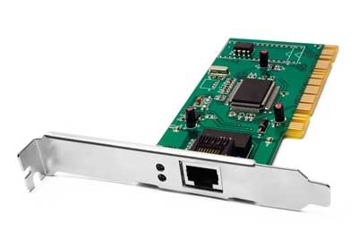

**Study of Transmission Media**

The below information is given for reference purpose only; you need to replace this with the information you have searched

**1. Twisted pair cable**

**Overview:**

* Twisted pair cables consist of pairs of insulated copper wires twisted together. They are used in various networking scenarios, including Ethernet and telephone systems.

**Types:**

* **Unshielded Twisted Pair (UTP):** Commonly used in Ethernet networks. UTP cables are not shielded from external interference, making them more susceptible to noise.
* **Shielded Twisted Pair (STP):** Includes shielding to reduce electromagnetic interference (EMI) and crosstalk, which improves performance in noisy environments.

**Characteristics:**

* **Bandwidth:** Typically supports data rates up to 1 Gbps (Gigabit Ethernet) for UTP and higher for STP.
* **Distance:** Effective up to about 100 meters (328 feet) for Ethernet networks.
* **Cost:** Generally lower-cost compared to coaxial and optical fiber cables.
* **Use Cases:** Common in local area networks (LANs), telephone systems, and some video surveillance applications.

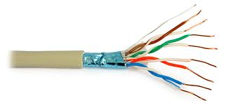

Fig 7.Twisted Pair Cable

**2. Coaxial cable**

**Overview:**

* Coaxial cables consist of a central conductor (usually copper) surrounded by an insulating layer, a braided metal shield, and an outer insulating layer.

**Characteristics:**

* **Bandwidth:** Higher bandwidth compared to twisted pair cables. Coaxial cables can support data rates of up to several Gbps.
* **Distance:** Effective over longer distances compared to twisted pair cables, often up to several kilometers (miles), depending on the application.
* **Cost:** Generally more expensive than twisted pair cables but less expensive than optical fiber cables.
* **Use Cases:** Commonly used for cable television (CATV), internet broadband connections, and some networking applications, especially where a robust shielded medium is needed.

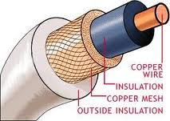

Fig 8.Coaxial Cable

**Optical Fiber**

**Overview:**

* Optical fiber cables use light to transmit data. They consist of a core (where the light travels), a cladding (which reflects the light back into the core), and an outer protective layer.

**Characteristics:**

* **Bandwidth:** Offers the highest bandwidth and data transmission rates among the three types. Capable of supporting data rates of several terabits per second (Tbps).
* **Distance:** Effective over very long distances, often exceeding 100 kilometers (62 miles) without needing signal boosting.
* **Cost:** Typically the most expensive of the three, both in terms of the cable itself and the installation process. However, prices have been decreasing.
* **Use Cases:** Ideal for backbone connections in networks, high-speed internet, telecommunications, and data center interconnections where high performance and long distance are critical.

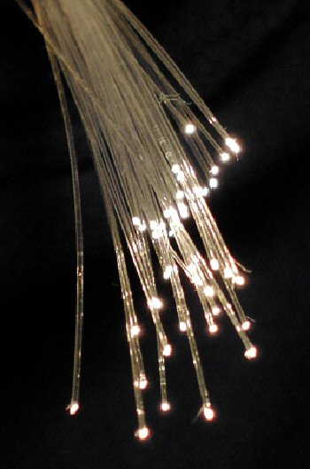

Fig 9.Fiber Optics Cable

**Summary**

The features of the connecting devices and transmission media can be explained in brief as follows:

**1. Hub:** A hub connects multiple devices in a network and operates at the Physical Layer (Layer 1). It broadcasts incoming data to all connected devices, leading to potential collisions and inefficiency. Suitable for simple networks but generally outdated for modern use due to lack of data filtering.

**2. Repeater:** A repeater amplifies and regenerates signals to extend network communication distances, operating at the Physical Layer (Layer 1). It enhances performance by overcoming signal attenuation, improving reliability over long distances in both LANs and WANs.

**3. Network Interface Card (NIC):** A NIC provides the hardware interface between a computer and a network, operating at the Data Link Layer (Layer 2). It converts data to electrical signals (wired) or radio signals (wireless) and is essential for network connectivity.

**4. Switch:** A switch segments networks into smaller subnetworks and operates at the Data Link Layer (Layer 2). It directs data packets based on MAC addresses, reducing collisions and improving efficiency by managing traffic and supporting various types of communication.

**5. Bridge:** A bridge connects multiple LANs and filters traffic between them, also operating at Layer 2. It reduces network traffic by segmenting and forwarding data based on MAC addresses.

**6. Router:** A router forwards data packets between networks, operating at the Network Layer (Layer 3). It manages traffic, connects multiple networks, and routes data to its destination IP address, facilitating internet and network connectivity.

**CONCLUSION:**

We have learned about various connecting devices and transmission medium.**Post Lab Questions**

1. Compare Hub, switch, bridge, and gateway and specify the use in different cases.

**Hub:**

* **Function:** A hub is a basic networking device that connects multiple devices in a network. It operates at the physical layer (Layer 1) of the OSI model.
* **Characteristics:** It broadcasts incoming data packets to all connected devices regardless of the destination. This can lead to network congestion and collisions.
* **Use Case:** Suitable for very small or simple networks where network traffic is minimal. Not recommended for modern, high-traffic environments due to inefficiency.

**Switch:**

* **Function:** A switch operates at the data link layer (Layer 2) of the OSI model. It intelligently forwards data packets only to the device with the specific MAC address for the packet.
* **Characteristics:** Reduces collisions and improves network efficiency compared to hubs by segmenting the network into smaller collision domains.
* **Use Case:** Ideal for medium to large networks. Provides better performance and scalability than hubs by managing traffic more efficiently.

**Bridge:**

* **Function:** A bridge operates at the data link layer (Layer 2) and is used to connect and filter traffic between two or more network segments.
* **Characteristics:** Can help in reducing traffic by segmenting a network into smaller collision domains. It can also be used to connect different LANs that use the same protocol.
* **Use Case:** Useful in extending or segmenting a network, and for connecting segments to reduce traffic load and improve performance.

**Gateway:**

* **Function:** A gateway operates at various layers of the OSI model, often working at the network layer (Layer 3) or higher. It acts as an interface between different networks that use different protocols.
* **Characteristics:** Translates and processes data between networks with different protocols or architectures.
* **Use Case:** Essential for connecting networks that use different communication protocols, such as connecting a corporate network to the internet or linking different types of networks (e.g., a network using TCP/IP and one using another protocol).

1. Which of the following device is used to connect two systems, especially if the systems use different protocols?

A. hub

B. bridge

**C. gateway**

D. repeater

E. None of the above

1. Frames from one LAN can be transmitted to another LAN via the device

A. Router

**B. Bridge**

C. Repeater

D. Modem